NAME: TUFAIL AHMED B
ROLL NO: 241901119

EXPERIMENT – 5
VIEW LAST ACTIVITY OF YOUR PC

AIM
To view the last activity of a PC using the LastActivityView tool.
PROCEDURE
- Download the LastActivityView tool for the Windows operating system.
- Extract the downloaded files, if required.
- Open the LastActivityView application.
- Allow the tool to collect activity information from the system.
- View the list of user actions and events displayed in the application.
- Examine the activity descriptions to understand the recorded events.
- Check the available date and time details for the recorded activities.
- Analyze the displayed information to identify the recent activities performed on the PC.

OBSERVATION
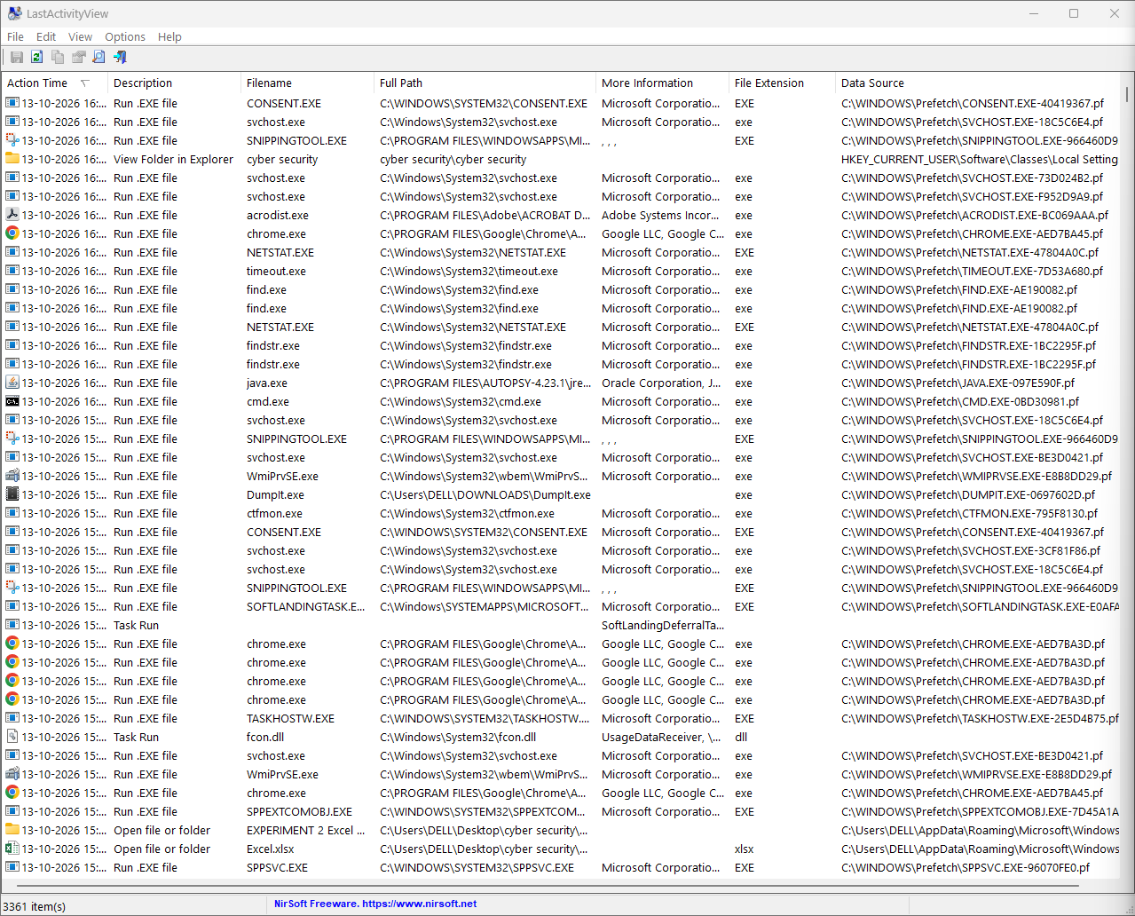

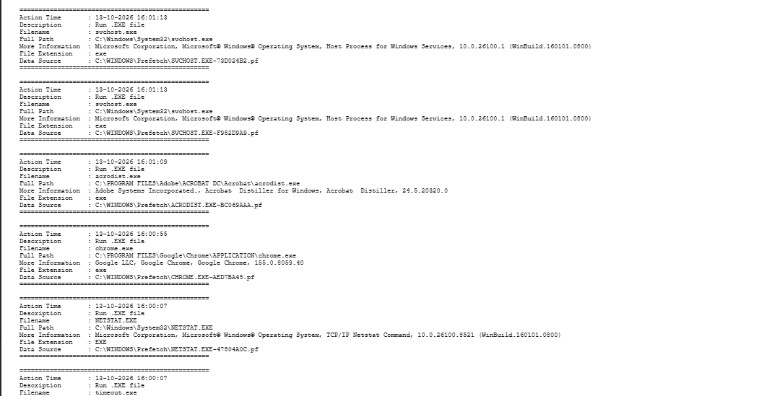

RESULT
Thus, the LastActivityView tool was used to examine and view the recorded activities and events of the PC.

